CUSTOM XPATH FUNCTION CREATION

## **Procedure**

1. Launch TIBCO Business Studio for Business Works and select **File** > **New** > **Project**.
2. In the New Project window, select **Plug-in Project** and click **Next**.

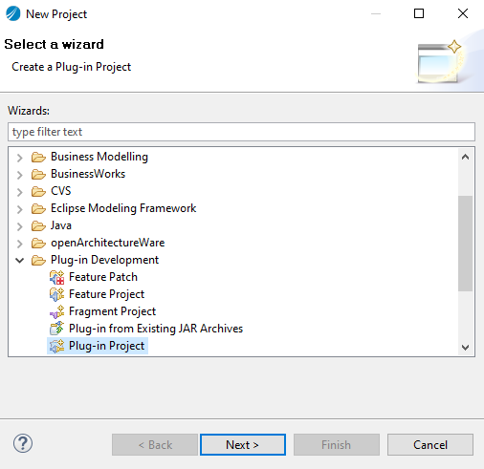

1. Specify a name for the project that reflects the XPath functions, for example, **CUSTUOM XPTH FUNCTIONS**. Retain all other default selections and click **Next**

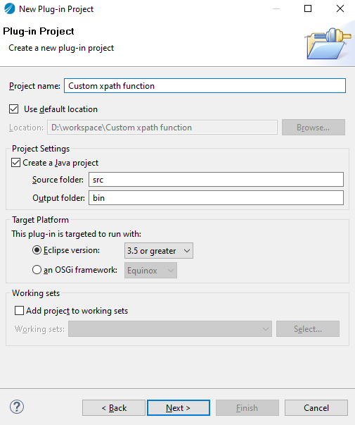

1. On the Plug-in Content page, locate the ****Options**** group and select **This plug-in will make contributions to the UI**

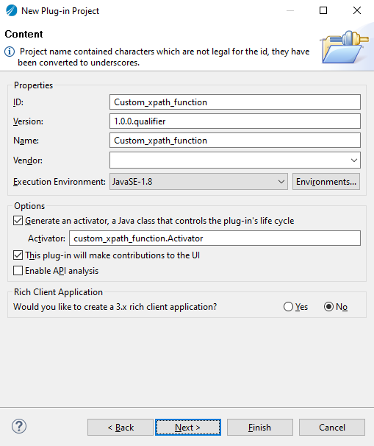

5.Accept all of the defaults and click **Next**

.

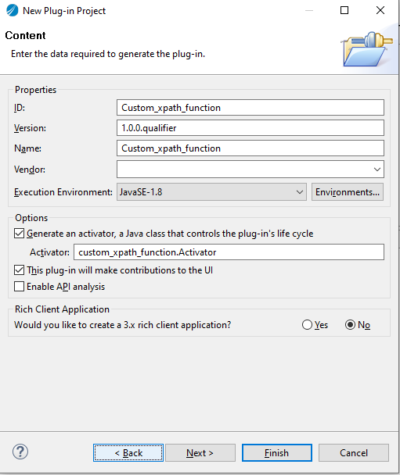

1. Select**Custom XPath Function Wizard** on the Templates page, and click **Next**

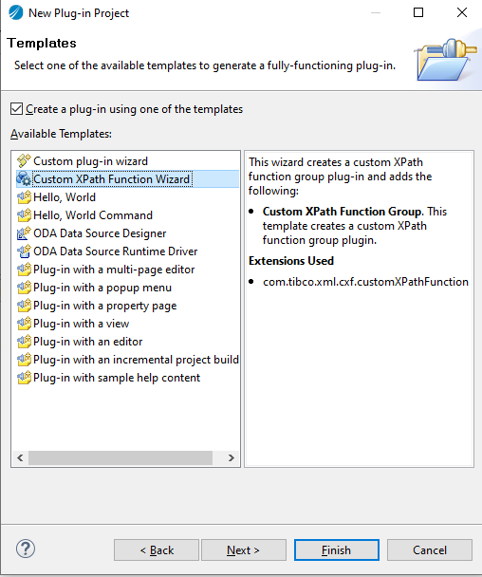

7.In the New Custom XPath Function Group plug-in project window provide values for the following fields and click **Next** to continue.

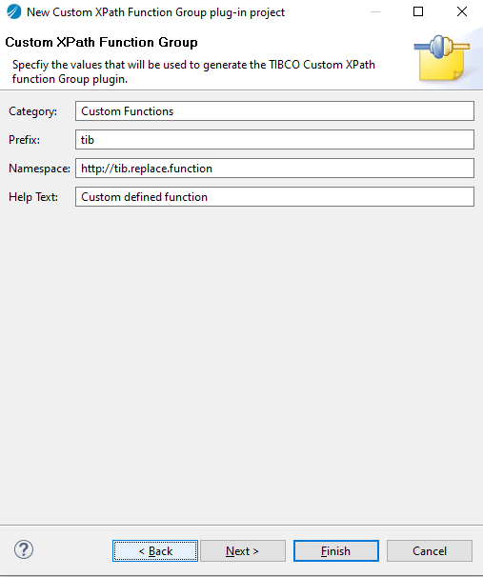

* 1. **Category**: The name of the category that includes the custom XPath functions
  2. **Prefix**: The prefix for the functions
  3. **Namespace**: The namespace for the functions
  4. **Help Text**: The description of the functions

8.Specify the ****XPath Function**** and ****XPath Function Parameters**** in the ****XPath Function Group Creation Section**** dialog

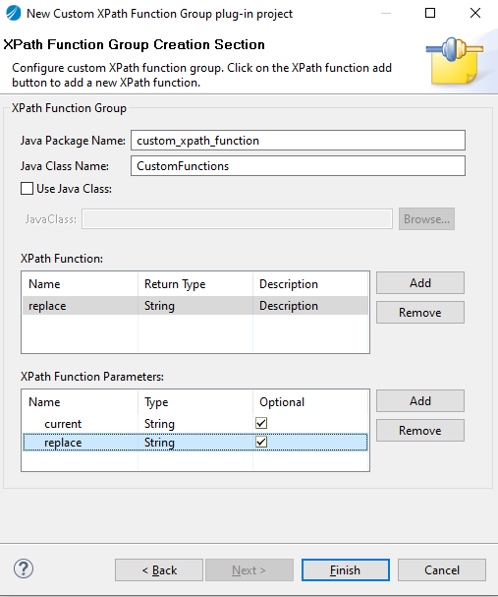

1. .Click the **Add** button located on the right side of the ****XPath Functions**** table and provide values for:
   1. **Name**: the name of the function
   2. **Return Type**: the return type of the function
   3. **Description**: the description of the function
2. Click the **Add** button located on the right side of the ****XPath Function Parameters**** table. Specify values for the following parameters and click **Finish**:
   1. **Name**: the name of the parameter
   2. **Type**: the data type of the parameter
   3. **Optional**: select the check box if the parameter is optional.

**1.**The Open Associated Perspective dialog displays. **Click Yes**.

**2.**TIBCO Business Studio for BusinessWorks opens in **Plug-in and the Plug-in Development perspective.**

**3.**Open the Java class in the newly created Custom XPath function plug-in and implement the Custom XPath function.

**4.**Now your Custom XPath function is ready for use at design time and run time.

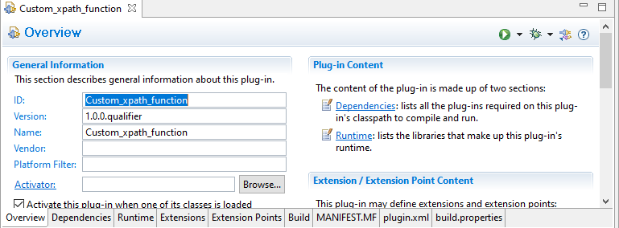

Use configuration in design and run time

## **Procedure**

1. Right-click the ****Custom X Path Function Plug-in**** project and select **Export** from the menu. On the Export window, select **Plug-in Development** > Deployable **plug-ins and fragments** and click **Next**.

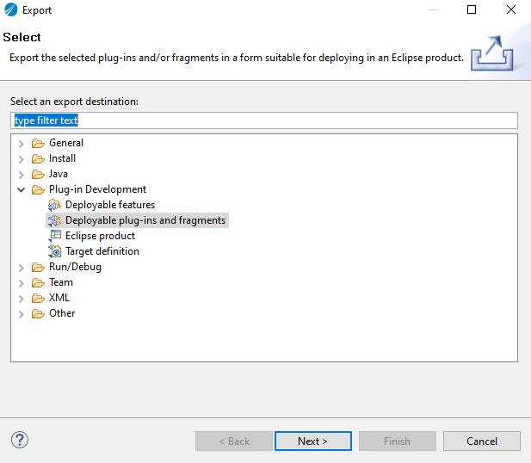

2.Select the **Install into host Repository** radio button on the ****Deployable plug-ins and fragments**** screen and click **Finish**.

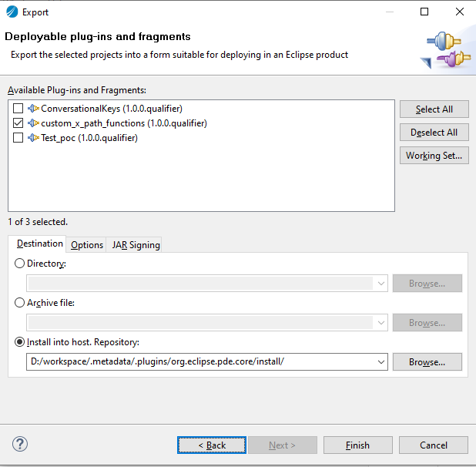

The Custom X Path function plug-in is exported into the TIBCO Business Studio for Business Works instance to use at design time.

You may be prompted with the following security warning message. Click **OK**.

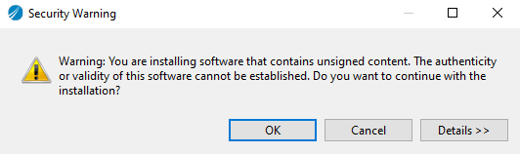

Next we can see the tab like below

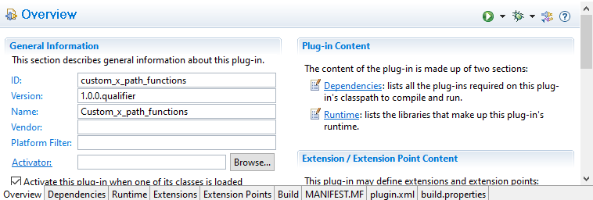

Next we can see the function as below tab

